

Documentation

**Overview**

1. **About Us.**

Our team consists of five members: Bek Zhaksybay, Aruzhan Baizakova, Ainur Karimbayeva, Malika Balabekova and Meruert Nassirdinova.

**Aruzhan Baizakova** (204095@astanait.edu.kz) – a leader of our team due to communication and leadership skills. Responsible for documentation, for the text (content) shown on the site and productive and convenient atmosphere among all of us and website design as well.

**Bek Zhaksybay** (204061@astanait.edu.kz) – is responsible for HTML code and design of buttons, fields. Searched for YouTube tutorials to know how to make a certain design.

**Malika Balabekova** ([204089@astanait.edu.kz](mailto:204089@astanait.edu.kz)) – is responsible for CSS code and design (website appearance).

**Ainur Karimbayeva** ([204145@astanait.edu.kz](mailto:204145@astanait.edu.kz)) – is also responsible for CSS code and website appearance.

**Meruert Nassirdinova** ([204026@astanait.edu.kz](mailto:204026@astanait.edu.kz)) – is responsible for making a documentation.

Communication Strategy

We have visited the university, even when we had no lesson offline, to make our team work. Sometimes there were no free tables to sit in open-space, so we were searching for free classroom to organize comfortable conditions for working. Ainur brought a lot of candies so we could get more glucose for higher brain activity. Not only did we use the knowledge that we obtained during the lessons, but also we looked for additional information to make our website’s appearance attractive.

1. **Motivation.**

Project is needed to be useful for AITU Canteen visitors, so they could know what is in stock. And also they can be able to reserve a table to avoid any troubles with overcrowding, when it is impossible to find a free table. We publish photos of today’s dishes to everyone knew what exactly they can buy in a certain day.

1. **High-level project scope.**

This project is new-brand, because we wanted to created a new website without using old codes, which we would change (what is really long-lasting procedure). We have concluded that creating new code will consolidate our knowledge in web development.

1. **Target audience/market.**

This project is targeted at Astana IT University’s students who like visit canteen and want to know what is in stock today. This information could be useful for teachers and other university workers as well.

# **Project goals and team interests**

1. Due to quarantine the canteen should not be overcrowded, so the first goal is to decrease overcrowding for 10% using reservation option. This may help all people stay heathy and avoid infection.
2. Make people be aware of what they can buy in canteen to save their money, because some students can not afford a meal from starbucks due to the price.
3. Save students’ time for searching a place where to eat. Because a trip to a restaurant is long-lasting, that’s why we should manage our time properly.

Our interests are:

1. Understand HTML
2. Understand CSS and learn how to make a beautiful design for logos and website overall.
3. Improve communication and leadership skills.

# **Phases**

1 Phase is creating a general html website.

2 Phase is making a css code to make the appearance of the website more attractive and more convenient to use.

3 Phase is adding a Bootstrap and Mailchimp codes to make our website more complex and professional.

# **Content structure**

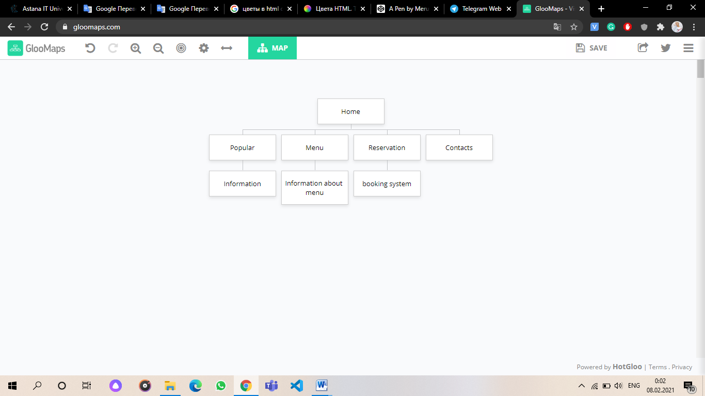Site map

**Content types**

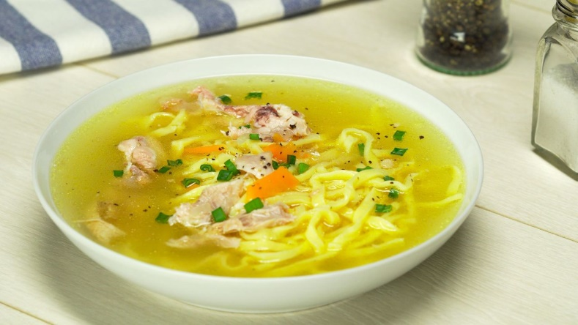The website contains the types of content like people, reservations, and menus for students of Astana IT University. The main clients are students and workers of the university. The reservation works in an example like order the place and chose the menu.

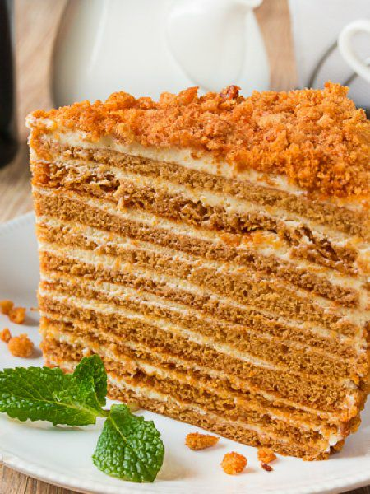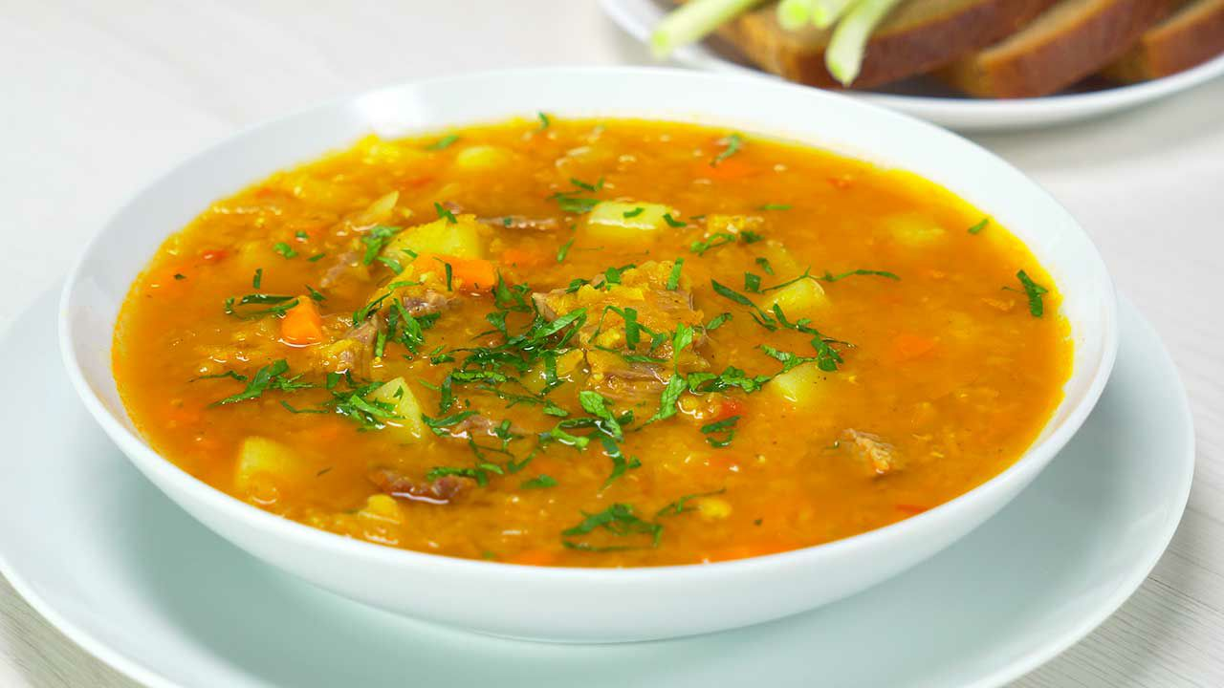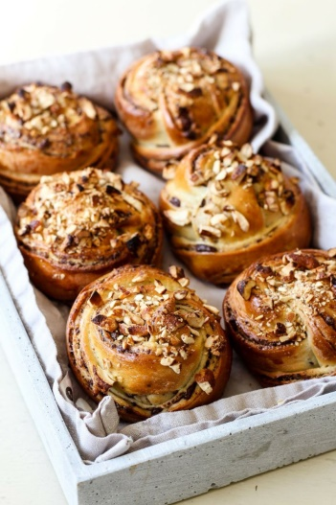**Design**

# 

# The colors used in the project are white and black, and #40c3ff also the font-size is 2em and 1.2 em, and 14px.

**Functionality**

Our site works in this format:

You first go to our website and then click on the reservation button

In this section, you can find out what food is available today and whether there are in the warehouse and prices of dishes. In addition to the menu, you can find out if there are free places in the dining room available to you and in order to avoid infection with the virus.

In the booking section, you must fill in these fields:

1. Email
2. Name
3. Surname/Lastname
4. Date of booking

**Availability**

Our website is accessible to all university students and employees. The design and fonts are simple and understandable for all clients and users of the site. Black and white backgrounds and bright pictures that immediately catch your eye and attract your attention immediately cheer you up. In addition, the simplicity of the site system, which is accessible and understandable for everyone, benefits both customers and services.

**Deadlines**

• Phase 1 – February 5, 18:00

• Phase 2 – February 6, 18:00

• Phase 3 – February 7, 23:00

## Summary

This teamwork helped us to learn how to work together, avoid conflicts if they occur, and come to a compromise like adults. We had a conflict when we were choosing a web-design, however we could overcome it.

Thus, not only did we improve our programming skills, but also we made our communication skills much better.

Also we have obtained new knowledge in CSS, we have discovered new web designs we could use.

Website: https://bekzhak.github.io/GroupProject/